Catch Week 3 of the hilarious episodes of the OSN Original ‘Yalla Neta’sha, Come Dine With Me’ for nonstop laughs
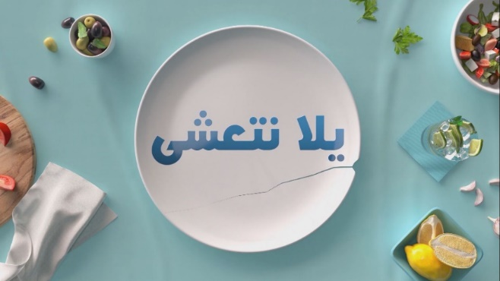

Dubai, United Arab Emirates – 29 November 2020: Week three’s episodes of OSN’s Original production ‘Yalla Neta’sha, Come Dine With Me’ were filled with more laughter, gossip, sarcasm and unfiltered commentary than ever now available on OSN Ya Hala Al Oula and the OSN Streaming app.
This week of Yalla Net’asha brought together Abdelrahman Solaiman, 30, from Egypt; Zeina Saoud, 35, Saudi Arabia; Edward Matti, 47, from Iraq; and Paula Assit, 28, from Lebanon. Each character is the polar opposite of the other, making for hilarious watching as personalities clash. This week, the four hopefuls show unfounded over-confidence in their cooking and hosting abilities which is reflected in harsh critiquing as they battle it out for the cash prize.
This week sees, the young fitness instructor Abdelrahman who is not accustomed to regularly hosting guests compete with socialite Saudi mother and influencer Zeina who is very proud of her cooking skills and traditional Saudi dishes – surprisingly her guests weren’t very impressed. The Lebanese entrepreneur Paula, who exudes elegance was a mess in the kitchen. Finally, audiences see how the quiet and unpredictable Iraqi business executive went over and beyond the call of duty and surprised everyone with his cooking and hosting skills.
Between misplacing crucial recipe ingredients, unfiltered critique of each other’s meals and hosting etiquette, and unexpected twists in the results, these episodes were filled with not-to-be missed laugh-out-loud moments:
- Abdelrahman, the fitness fanatic, was so obsessed with working out that he burned his dish on the stove as he got distracted with doing pushups. Also, once it was time to eat, Paula did not fail to point out how unimpressed she was with table layout presentation – no detail is left uncriticized!
- The guests got into a prolonged debate on whether influencers are legitimate content creators or posers for the camera.
- Audiences are left to decide if taking a break in between discussions to check your phone is rude or acceptable.
- Zeina challenged the norm by proving that there is no such thing as too many twirls in between preparing her dishes and flaunted her over-confidence as she prepared her Saudi recipes with pride – yet her guests were not very impressed. Tough crowd!
- Paula found it very hard to take honest feedback and guilted her guests into pretending they liked her food. It was the funniest of all four episodes where it was very evident that she has not stepped in a kitchen before.

In a nutshell OSN has built reality TV like a drama series and audiences are up for surprising results. Narrated by Egyptian comedian Khalid Mansour, audiences can catch these uncompromising hilarious yet heartfelt moments and much more of the 45-episode Arabic series every evening from Sunday to Thursday on OSN Ya Hala Al Oula and the OSN Streaming app.
-ENDS-
About OSN
OSN is the region’s leading entertainment business with the rights to broadcast in 17 countries across the MENA. The company is owned and operated by Panther Media Group, registered in the Dubai International Financial Centre (DIFC) and has two shareholders, KIPCO and the Mawarid Group Limited.
OSN has a history of providing exceptional value for customers with its focus on exclusive and in-demand content, and innovative digital platforms for anywhere, anytime access.

OSN is the exclusive distributor of The Walt Disney Company’s new Disney+ Originals in the Middle East region, across both its box and streaming services. OSN’s strength is its unbeatable range of exclusive programming and best-in-class entertainment led by its long-term partnerships with studio majors including Disney+, Disney, HBO, NBC Universal, Fox, Paramount, MGM, and Sony to name a few.
OSN is the home for premium and nowhere-else content in Arabic, English, Filipino. OSN broadcasts the latest content at the same minute as in the US, including popular series, blockbuster movies, and the best in kids and lifestyle programming. In addition, OSN also provides entertainment content for devices such as laptops, tablets and mobile phones via its online and mobile app entertainment platform, offering movies and series on the go.

OSN has been at the forefront of digital technology innovation in the Middle East introducing OSN on Demand, the region's first VOD service.

OSN’s ambition is to deliver entertainment everywhere for everyone, which is informed by the company’s three key pillars: A customer-first approach, unrivalled exclusive content and unbeatable value.

For more details please contact:
Dana Oraibi
Impact Porter Novelli
d.oraibi@ipn.ae
Mob: +9715 5 589 6494

