Media Alert

OSN unveils multi-year deal with Intigral
The deal includes offering OSN’s content via JAWWY TV

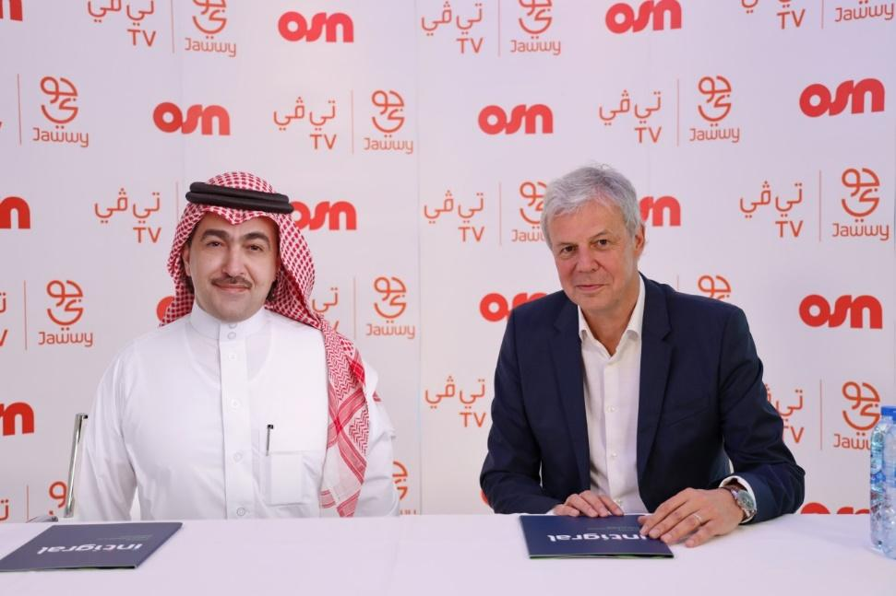

The new partnership sees OSN continue its expansion in the Middle East
Dubai, UAE –15 April 2020: OSN, the region’s leading entertainment network has signed a hallmark multi-year deal with Intigral, the media arm of STC and leading provider of digital entertainment and sports in MENA, for its flagship Home and OTT service, Jawwy TV. This strategic partnership between OSN and Intigral significantly reinforces the collaboration at a time where TV consumption and streaming are recording unpreceded levels of viewership and consumption.
The new partnership sees Intigral secure first access to OSN’s new general entertainment channel “OSN Mix”. This brand-new initiative aims to offer viewers a unique window into OSN’s world of Entertainment featuring a curated selection of OSN’s best series, movies, kids and factual entertainment programs that will engage all members of a household.
On the top of “OSN Mix”, thanks to this enhanced partnership, Jawwy TV subscribers will have access as part of their telecom bundles to a host of channels ranging from Arabic with OSN’s “Yahala” and “ART” channels that provide the most sought after Arabic productions in the region, to premium Turkish series and the best of kids entertainment with world-class channels as well as unique documentaries and factual entertainment.
Patrick Tillieux, CEO of OSN said: “Intigral is such a natural partner for OSN. We aim to bring entertainment and joy to a broad audience with quality content. This agreement is the result of a great relationship that has been built over many years. It is based on a common view of the future and confidence in each other.”
Hamoud Al Rumayan, CEO of Intigral said: ”Jawwy TV is home to the richest selection of entertainment and we see a bigger collaboration happening with OSN. The addition of OSN to our large portfolio of content not only enhances the attractiveness of our proposition but also caters to the needs of our beloved clients in KSA and other regional markets. In a time where TV is the center of every household, we proud ourselves of this timely and unique enhancements.”
Zahra Zayat, Senior Vice President – Digital, OTT and Telco of OSN, said: “This is only phase one of a much bigger collaboration and partnership. This new partnership with Intigral, is a testament to OSN’s continued commitment to bring the best of entertainment to audiences throughout KSA and the region. Intigral’s Jawwy TV, is the perfect fit for our premium content thanks to the amazing reach, rich content proposition and user-friendly platform. This is just one step towards nurturing this very special partnership and more exciting announcements will be shared soon.”
Tony Saab, VP of Operations at Intigral said: “Intigral is thrilled to expand its already rich selection of entertainment offerings to include OSN’s renowned programs enjoyed by numerous viewers in the region. We are confident that this agreement will add great value to our audiences and will further enhance Intigral’s position as a leading provider of OTT entertainment services in MENA.”
OSN content is now available to Jawwy TV customers in KSA, whilst STC subscribers in Bahrain, Kuwait, Oman and Saudi Arabia can access OSN through a range of bundles and offers.
Subscribers of STC, Mofawtar 4 and 5 will be able to watch OSN’s rich selection of popular shows and entertainment programs on the Jawwy TV app by visiting www.jawwy.tv, downloading Jawwy TV application from app stores, or contacting STC customer service to request their own home device.

