OSN TO AIR NEW TAYLOR SWIFT CINEMATIC CONCERT EXPERIENCE “folklore: the long pond studio sessions”
FROM DECEMBER 4TH

- Taylor Swift Releases Full Performance of Grammy-Nominated “Exile” Featuring Justin Vernon (Bon Iver)

- Taylor Swift’s “Folklore: The Long Pond Studio Sessions” Will Be Available To Watch Exclusively on the OSN Streaming App

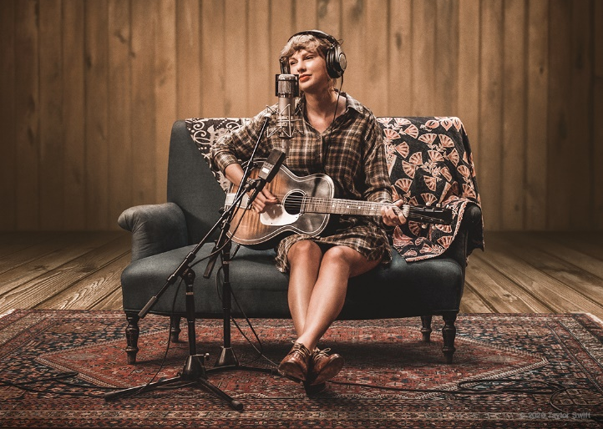

“EXILE (feat. Bon Iver)” VIDEO: https://www.youtube.com/watch?v=o5SQIECedTY
WATCH TRAILER: https://www.youtube.com/watch?v=jgdFUoZzCI0

30 November 2020, Dubai, UAE: OSN, the region’s leading entertainment hub, will be the Middle East’s exclusive home of a new cinematic concert experience released by Taylor Swift. The multi-GRAMMY winning artist transforms her five-time GRAMMY nominated Album of the Year into “folklore: the long pond studio sessions”, available on OSN from December 4th on the OSN streaming app.

Swift, Aaron Dessner (The National), Jack Antonoff (Bleachers) and Justin Vernon (Bon Iver) created an album that crossed genres –- a musical journey that allows us to cry and laugh, and during these trying times, makes us feel like we’re not quite so alone. They recorded “folklore” thousands of miles apart from each other and had never been in the same room together – until now.

Taylor, accompanied by co-producers Aaron Dessner and Jack Antonoff along with a guest appearance by Justin Vernon (Bon Iver), performs each song in order of her critically adored, five star album, “folklore” and for the very first time, reveals the stories and secrets behind all 17 songs.

Swift announced the news of “folklore: the long pond studio sessions” on social media. The film drops on OSN on December 4th. Fans can subscribe to the OSN streaming app for only $9.50 / month or sign up for a 7-day free trial to watch the film across multiple devices including Smart TV’s, laptop’s, tablet’s and on Apple and Android smartphones through the mobile app. Viewers can also enjoy OSN’s unrivalled selection of Hollywood content including a premium range of movies, series, documentaries, boxsets, kid’s content, and Arabic and Turkish productions.

Watch the trailer for Swift's Folklore film here: https://www.youtube.com/watch?v=jgdFUoZzCI0

